

**COP-1000:  Programming Logic**

**Assignment 0-1**

Document Version: 0.1

Version Date:

Created By:

# Document Version Control

|  |  |  |  |
| --- | --- | --- | --- |
| Version | Date | Author | Rationale |
| 0.1 |  |  | First Draft |

# Technical Specifications

## Link to GitHub Repository

## Screenshot of working IDE of choice

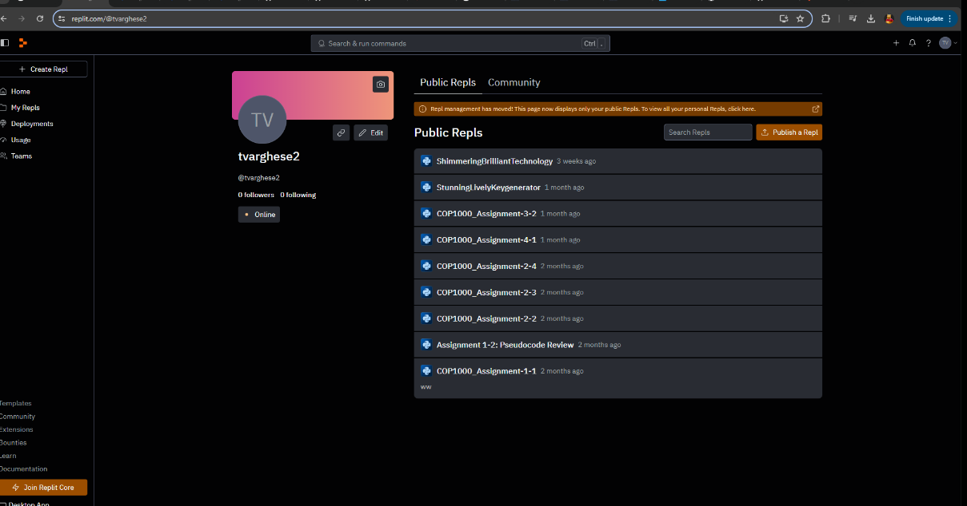

## Screenshot of Lucidchart account

